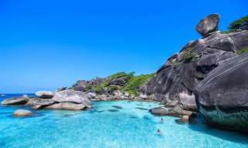
Phuket Similan Island Tour by Speedboat (Full Day with Lunch)
(Adult 3,000.- Baht / Person Child 2,000.- Baht / Person)

The Similan Islands national park is one of the most beautiful marine national parks in Thailand. It was rated by American Diving magazine as one of its top ten dive sites in the world. The beach is not be missed either. Containing golden powdery sand, it sits next to mirror like waters, the likes of which you’d imagine paradise to possess – a place everyone should visit once in there.

Itinerary
- Pick up from the hotel to Tap-Lamu Pier Thaimuang District Pang-Nga province and have some coffee or tea.
- 08.30 am. Departure from the pier to Similan archipelago by speed boat.
- 10.00 am. Snorkeling in the area of the beautiful fishes and coral at Bangu Island (Island No.9).
- 11.30 am. Lunch with Thai food /set menu and relax on Similan Island (Island No.8).
- 01.30 pm. Transfer by speed boat to snorkeling at Koh Miang (Isl.No.4 ), Connecting to Koh Payu (Isl.No.7) for snorkeling.
- 03.00 pm. Departure from Similan archipelago to Tap-Lamu pier.
- 04.30 pm. Arrive at the pier and back to the hotel.

Tour Price included :
- Round trip transfer by Speed boat and Minibus.
- Lunch meal.
- National park entrance fee.
- Life jacket, Mask & Snorkel and Fin.
- Insurance for every tourist.
Price exclude :
- Personal Expense
- Service charge 3.5% for paying by credit card charge
*PRICE AND ITINERARY ARE SUBJECT TO CHANGE WITHOUT PRIOR NOTICE*

