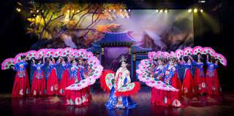

Phuket Simon Cabaret Show
(VIP Seat + Transfer Adult 1,200.- Child 1,000.- Baht / Person)

Let your imagination fly...
Since opening in October 18, 1991, Phuket Simon Cabaret has established itself as a market leader of professional entertainment venue.
For sheer entertainment, our set designs are outstanding, costume extravagant and the performers glamorous, in the exclusive, luxurious and intimate theatre with hi-tech sound and lighting equipment.
Our show is truly international featuring modern and traditional acts from around the globe in English and alternative languages.
You will arrive relaxed but will leave confused as our performers is more of a man than you will ever be and even more of a woman too!
Show Time :
3 Times daily : 06:00 P.M., 07:45 P.M. and 09:30 P.M.
Price exclude :
- Personal Expense
- Service charge 3.5% for paying by credit card charge

*PRICE AND ITINERARY ARE SUBJECT TO CHANGE WITHOUT PRIOR NOTICE*

