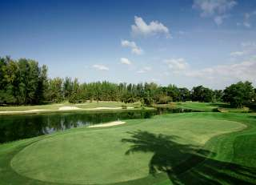

Golf Tour Package Itinerary for the Ultimate Phuket Golf Resort & Villa Package

This golf tour package can be customized according to your preferences.
Day 1 - Arrival
Arrive Phuket International Airport and transfer to your golf resort.
Day 2 - Golf at Laguna Phuket Golf Club
Golf at Laguna Phuket Golf Club (redesigned resort course, host of 2009 Thailand Open, is best manicured Phuket course).
Day 3 - Sightseeing
Enjoy a half day "Best of Phuket" sightseeing tour including all of the island's hot spots.
Day 4 - Golf at Blue Canyon Country Club, Lakes Course
Golf at Blue Canyon Country Club, Lakes Course (excellent layout with the best finishing holes in Phuket).
Day 5 - Golf at Loch Palm Golf Club
Golf at Loch Palm Golf Club (a local long-time favorite for its unique, fun & fair design).
Day 6 - Free
Free day at leisure on your own.
Day 7 - Golf at Phuket Country Club
Golf at Phuket Country Club (island's oldest course; great views and scoring opportunities).
Day 8 - Free
Free day at leisure on your own.
Day 9 - Golf at Red Mountain Golf Club
Golf at Red Mountain Golf Club (Phuket's most exciting course; dramatic scenery and great golf).
Day 10 - Free
Free day at leisure on your own.
Day 11 - Departure
Leave your Villa and transfer to Phuket airport for departure.

Start Location : Phuket
Tour Length : 11 Days (Length can be adjusted)
Price from : 79,900

Inclusions :
- All accommodations
- Daily breakfast
- All green fees
- 1 caddie per golfer at each course
- All airport and golf transfers
- All transfers by VIP high roof touring van or equivalent
- All sightseeing tours with English speaking guide
- 24/7 golf hotline staffed by knowledgeable service personnel
- All taxes and service charges

Exclusions :
- International airfare
- Personal items, drinks, and gratuities
- International airfare
- Personal items, drinks, and gratuities
Recommended Hotels :
- 5 Star Trisara Phuket Villas & Residences
- 5 Star Outrigger Laguna Phuket Resort and Villas
- 5 Star Andara Resort & Villas
- We have a wide range of 3 - 5 star hotels available. To meet your preferences and budget please contact us for further information
Extra Info : Numerous other villas and golf resorts are also available.

