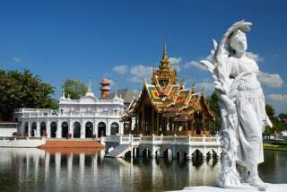

Ayutthaya / Bangpa-In by Bus
(1,600.- Baht / Person)

06.20 a.m. Pickup from hotels
07.40 a.m. Depart Bangkok
09.30 a.m. Arrive Banj-pain and visit summer palace Bang Pa Inn
- Wat Panan Cheon
- Wat Yai Chai Mongkol
- Lunch
- Wat Srisan Pech and palace
02.00 p.m. Depart for Bangkok and sending hotels.
Price Exclude :
- Personal Expense
- Service charge 3.5% for paying by credit card charge
*PRICE AND ITINERARY ARE SUBJECT TO CHANGE WITHOUT PRIOR NOTICE*

