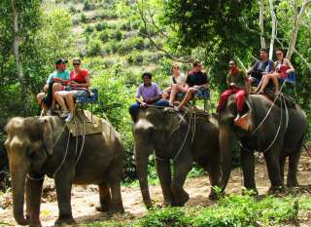
Phuket Elephant Trekking 1 Hrs. + R/T Transfer
(Adult 1,400 / Child 1,300 Baht/Person)

Experience the best elephant trek in Phuket. Learn more about Asian elephants and meet our young elephants to see how they are trained.
Tour Price included :
- Elephant trek 60 mins.
- Closely touch & see baby elephants show.
- Transfer.
Tour Price included :
- Transfer by air-conditioned minibus
- Lunch/drinking water/fruit
- Elephant riding 30 min
- Rafting 5 km
- English speaking tourist guide
- Insurance
Price exclude :
- Personal Expense
- Service charge 3.5% for paying by credit card charge
*PRICE AND ITINERARY ARE SUBJECT TO CHANGE WITHOUT PRIOR NOTICE*

