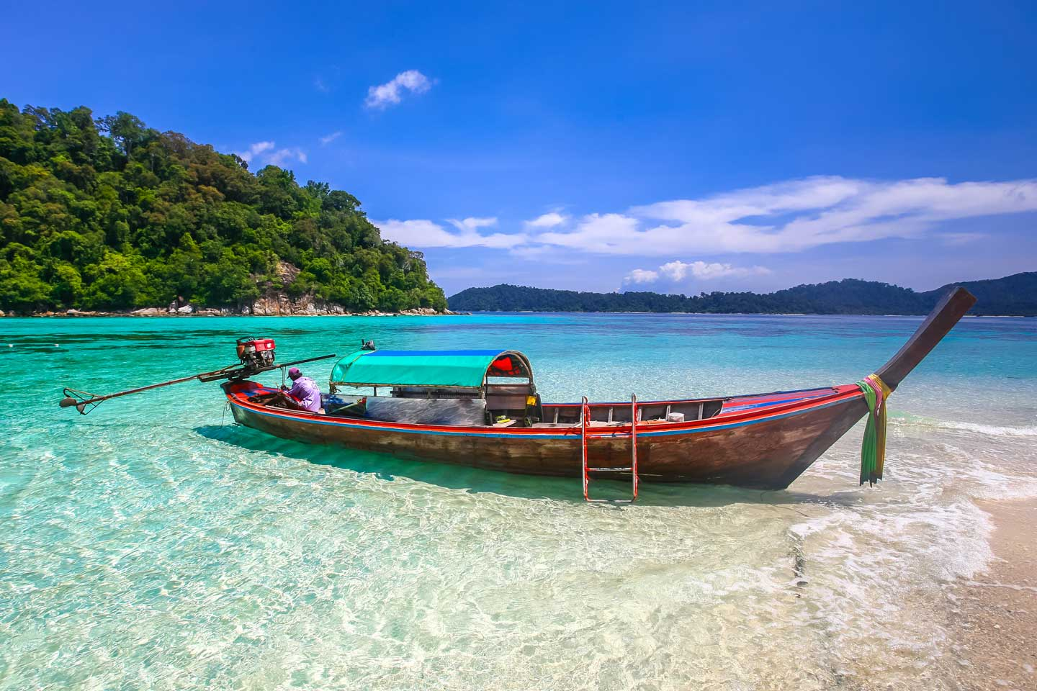
Koh Chang Package 3 Days 2 Nights 6,900.- Baht / Per person
(Min. 2 Persons)

DAY 1
06.30 a.m. Depart from the resort Bangkok office by van.
12.00 a.m. Arrive at Koh Chang Resort & Spa
Get welcome drink & check in
Have lunch at the sunset seaside restaurant.
Evening dinner.

DAY 2
07.00 a.m. Breakfast
09.00 a.m. Sightseeing and skin dive at Koh Yuak with lunch box.
Evening dinner.
DAY 3
07.00 a.m. Breakfast
09.00 a.m. Take a trip to Klongplu Waterfall
12.00 a.m. Have lunch and get ready for departure.
01.15 p.m. Departure from the resort.
About
07.30 p.m. Arrive at your hotel in Bangkok and farewell.

The Package Included :
- Transfer round trip: Bangkok - Resort - Bangkok
- Welcome drink
- 2 Nights’ accommodation (twin sharing) + 7 meals.
- 2 Activities
Exclusions:
- Optional tours or excursions not mentioned in the program
- Other meals not mentioned in the program
- Personal expenses
- Services change 3.5% pay by credit cards
Addition :
- For The Squid Cashing (07.00 PM.-10.00 PM.) Only 390 Bath/Person (includes equipment + grill + water).
- New Year Eve (31 Dec.) : 1,050 Bath Will Be Added For Grand Dinner Extra Cost.
Remark : Pick up anywhere in Bangkok before 05.30 A.M. : Extra charge 300 Baht/person.
* PACKAGE PROGRAME IS SUBJECTED TO CHANGE WITHOUT PRIOR NOTICE*

