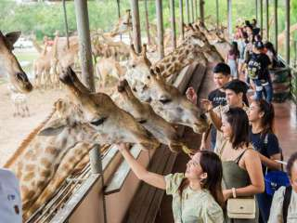

Safari World (Baht 1,200.- / Per person)

08.00 a.m. Pick up from the hotel
09.00 a.m. Visit safari park drive through the scenic 100 acre, where you will have the unique opportunity for the closest encounter with the rare and endangered of the animal kingdom
12.00 a.m. International buffet lunch
01.00 p.m. Enjoy marring park, housing a spectrum of animal from land , sea and air and setting the scenes for 7 Amazing World class shows . From live action stunt spectacular to performances by animal.
04.00 p.m. Leave for Bangkok
05.30 p.m. Return to the hotel
Price exclude
- Personal Expense
- Service charge 3.5% for paying by credit card charge
*PRICE AND ITINERARY ARE SUBJECT TO CHANGE WITHOUT PRIOR NOTICE*

