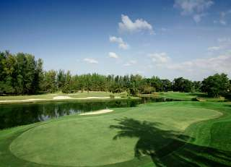

Golf Tour Package Itinerary for the Private Villa Phuket Golf Resort Package

This golf tour package can be customized according to your preferences.
Day 1 - Arrival
Arrival Phuket International Airport and transfer to hotel.
Day 2 - Golf at Laguna Phuket Golf Club
Golf at Laguna Phuket Golf Club (redesigned resort course, host of 2009 Thailand Open, is best manicured Phuket course).
Day 3 - Sightseeing
Sightseeing. Complimentary Half Day Island Tour.
Day 4 - Golf at Blue Canyon Country Club, Lakes Course
Golf at Blue Canyon Country Club, Lakes Course (excellent layout with the best finishing holes in Phuket).
Day 5 - Free
Free Day at Leisure
Day 6 - Golf at Red Mountain Golf Club
Golf at Red Mountain Golf Club (Phuket's most exciting course; dramatic scenery and great golf).
Day 7 - Golf at Blue Canyon Country Club, Canyon Course
Golf at Blue Canyon Country Club, Canyon Course (site of Tiger Woods' 1998 Asian victory and host of 2007 Johnnie Walker).
Day 8 - Departure
Departure and transfer to Phuket International Airport.

Start Location : Phuket
Tour Length : 8 Days (Length can be adjusted)
Price from : 74,250

Inclusions :
- 7 x nights in Pool Villa with breakfast
- 4 x rounds of golf (Red Mountain, Blue Canyon, Canyon Lakes and Laguna Golf), cart included at Red Mountain
- Private airport transfers
- Golf course transfers to and from all courses via private high top VIP touring van or equivalent
- Golf hotline staffed by knowledgeable English and Thai speaking service personnel
- All taxes and compulsory service charges included
- Complimentary Island Tour
- Complimentary Wi-Fi internet access
Exclusions :
- International airfare
- Personal items, drinks, and gratuities
- International airfare
- Personal items, drinks, and gratuities
Recommended Hotels :
Extra Info : Please, note that we have numerous villas and golf resorts available that can be easily combined with this suggested Phuket golf holiday package.

