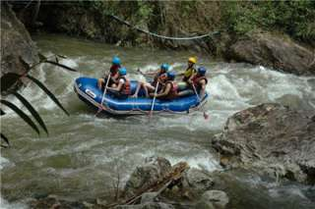
Phuket Phang-Nga (White Water Rafting + Elephant Trekking)(Adult 2,000.- Baht / Person Child 1,600.- Baht / Person)

If you have fancied trying out some white water rafting, why not take this opportunity here in Thailand. The powerful streams have always attracted the adventure-hungry, white water rafting enthusiasts. But you don’t need to be a pro to join because you can start at grade 2-3 and the operator provides a training session before you jump into the raft. Riding on the elephant back and swaying through the tropical forest is quite an unforgettable experience as well. The gigantic mammal will walk you along the rocky stream with the rainforest hillside as a background. At the elephant camp you will be amazed by the young elephant shows.
Itinerary :
07:15 - 08:00 a.m. Pick up from Hotel.
• Visit to Suwanakuha Temple (Monkey Cave)
• Rafting Training by Experienced Instructor
• White Water Rafting
• Lunch
• Elephant Trekking
• Jungle walk to Tone Pariwat waterfall
• Herb Sauna or Relax
04:00 - 05.30 p.m. Transfer back to Hotel.
Tour Price included :
- Transfer by air-conditioned minibus
- Lunch/drinking water/fruit
- Elephant riding 30 min
- Rafting 5 km
- English speaking tourist guide
- Insurance
Price exclude :
- Personal Expense
- Service charge 3.5% for paying by credit card charge

*PRICE AND ITINERARY ARE SUBJECT TO CHANGE WITHOUT PRIOR NOTICE*

