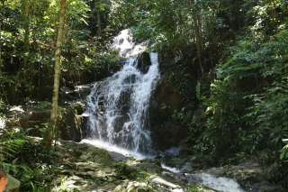

Phuket Rain Forest (7 in 1 Safari) Tour by van + Lunch
(Adult 1,700.- Baht / Person Child 1,400 Baht/Person)
If you love nature - this tour is for you!
By Bamboo raft, natural stream will take you to exiting journey through the jungle, where can see tropical birds, exotic fruits and amazing landscapes.
On back of Elephant, you will perform another trip to the jungle and will see natural wonders of Khaolak area. In Thai Navy Base will learn about Sea Turtles. On the way will stop at Pineapple farm, Mangostin farm and will see traditional life of Phang Nga province.
This is safe, cool, educational and exiting tour. It will be pleasant day for the whole family.

Itinerary:
07.30 - 08.30 a.m. Hotel pick up
- - Visit Mangosteen Plantation & OTOP Center
- - Visit Pineapple Plantation & Local life style at
- - Visit Save the Sea-Turtle project at Navy Base
- - Elephant Trekking through the Jungle 1 hour
- - Waterfall
- - Delicious lunch at private riverside restaurant
- - Bamboo Rafting along the Natural stream at “Wang Kheng Koo” location, with very beautiful landscape
03.00 - 03.30 p.m. Return transportation back to hotel

Tour Price included :
- Transfer by air-conditioned minibus
- Lunch/drinking water/fruit
- Elephant riding
- Bamboo Rafting
- Tourist guide
- Insurance
Price exclude :
- Personal Expense
- Service charge 3.5% for paying by credit card charge

*PRICE AND ITINERARY ARE SUBJECT TO CHANGE WITHOUT PRIOR NOTICE*

