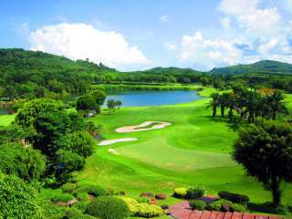
Golf Tour Package Itinerary for the Phuket Golf Resort Luxury Villa Package

This golf tour package can be customized according to your preferences.
Day 1 - Arrival
Arrive Phuket and transfer to your luxury Villa.
Day 2 - Free
Free Day at Leisure
Day 3 - Golf at Blue Canyon Country Club, Canyon Course
Golf at Blue Canyon Country Club, Canyon Course (site of Tiger Woods' 1998 Asian victory and host of 2007 Johnnie Walker).
Day 4 - Free
Free Day at Leisure
Day 5 - Golf at Blue Canyon Country Club, Lakes Course
Golf at Blue Canyon Country Club, Lakes Course (excellent layout with the best finishing holes in Phuket).
Day 6 - Free
Free Day at leisure.
Day 7 - Golf at Red Mountain Golf Club
Golf at Red Mountain Golf Club (Phuket's most exciting course; dramatic scenery and great golf).
Day 8 - Departure
Leave your Villa and transfer to Phuket International Airport.

Start Location : Phuket
Tour Length : 8 Days (Length can be adjusted)
Price from : 65,000

Inclusions :
- Accommodation at Pura Vida Villas, Pool Villa
- Daily breakfast
- All green fees
- 1 caddie per golfer at each golf course
- All airport and golf transfers
- All transfers via private high top VIP touring van or limousine
- 24/7 golf hotline staffed by knowledgeable service personnel
- Local knowledge, expertise, suggestions, and support throughout trip
- All taxes and compulsory service charges
Exclusions :
- International airfare
- Personal items, drinks, and gratuities
- International and domestic flights and any related fees
- Personal items, meals, gratuities
Recommended Hotels :
- 5 Star Patong Hill Villas
- We have a wide range of 3 - 5 star hotels available. To meet your preferences and budget please contact us for further information.

Extra Info :
- Please, note that we have numerous villas and golf resorts available that can be easily combined with this suggested Phuket golf holiday package.

