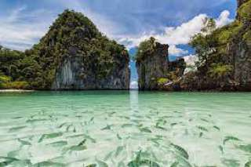

Phuket Krabi 4 Island Tour by Big boat + speedboat (Tour from Phuket)
(Adult 2,000.- Baht / Person Child 1,500.- Baht / Person)

On this trip, we are going by the Luxury Cruiser to Krabi and continue by Speed Boat to park on the Beaches of Porda Island, Chicken Island, Tub Island, Talewalk (Separated Sea) and Pranang Bay.
Chicken Island : Enjoy swimming & snorkeling among coral reef and fishes.
Porda Island : Relax, sunbathing and walking around the Island by the beach. As well this is very good place to play water sport
Some time, the low tide of water makes the water separated to show the white sandy beach road on the ocean from the one Island (Porda Island) to the Other (Tub Island)
Railay Beach : Visit the quietest beach of Krabi, Railay Beach. And lunch will be served there.
Phranang Cave : Visit Phra - Nang Cave to learn the history which is the secreted image for the local people. The story of the princess who hide big treasures here.
Price exclude :
- Personal Expense
- Service charge 3.5% for paying by credit card charge

*PRICE AND ITINERARY ARE SUBJECT TO CHANGE WITHOUT PRIOR NOTICE*

