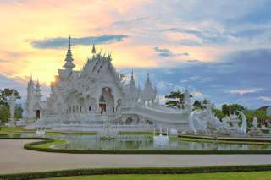

Chiang Rai City & Temples Tour

Half Day Tour (08:30 a.m. - 12:00 a.m. /01:00 p.m. - 04:30 p.m.)
See Chiang Rai City by "samlor", a comfortable, three wheeled, human powered tricycle, then visit the world famous Wat Phra Kaew where the Emerald Buddha image was once enshrined. Move on to Wat Phra Singha where one of Thailand's most beautiful Buddha images is now enshrined. Finish up the day by viewing the statue of King Mengrai , who was the builder of Chiang Rai City, then the Hill Tribe Museum and a local market.

Half Day Tour  (Price Per Person in Thai Baht ) | 1 | 2 | 3-5 | 6-8 | Join Tour
Chiang Rai City & Temples Tour | 2400 | 1500 | 1200 | 1100 | -
*PRICE AND ITINERARY ARE SUBJECT TO CHANGE WITHOUT PRIOR NOTICE*

