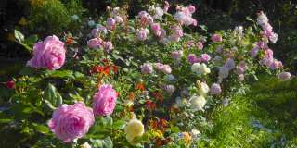

Rose Garden ( Baht 800.- / Per Person)

12.45 a.m. Leave Bangkok for ROSE GARDEN
02.30 p.m. Visit ROSE GARDEN THAI VILLAGE with Thai style house offering a display of Thai tradition such as monk's ordination, Thai wedding ceremony, Thai boxing, folk art and Thai folk dance
04.00 p.m. Leave ROSE GARDEN for Bangkok
Price Exclude :
- Personal Expense
- Service charge 3.5% for paying by credit card charge
*PRICE AND ITINERARY ARE SUBJECT TO CHANGE WITHOUT PRIOR NOTICE*

