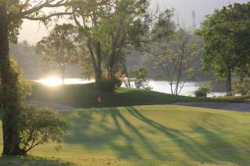
Golf Tour Package Itinerary for the Phuket Golf & Beach Holiday Special

This golf tour package can be customized according to your preferences.
Day 1 - Arrival
Arrive Phuket International Airport and transfer to hotel.
Day 2 - Golf at Phuket Country Club
Golf at Phuket Country Club (island's oldest course; great views and scoring opportunities).
Day 3 - Golf at Red Mountain Golf Club
Golf at Red Mountain Golf Club (Phuket's most exciting course; dramatic scenery and great golf).
Day 4 - Golf at Blue Canyon Country Club, Lakes Course
Golf at Blue Canyon Country Club, Lakes Course (excellent layout with the best finishing holes in Phuket).
Day 5 - Departure
Transfer to Phuket International Airport for departure.

Start Location : Phuket
Tour Length : 5 Days (Length can be adjusted)
Price from : 26,900
Inclusions :
- All accommodations
- Daily breakfast
- All green fees
- 1 caddie per golfer at each golf course
- All airport and golf course transfers
- All transfers by VIP high roof touring van or equivalent
- 24/7 golf hotline staffed by knowledgeable service personnel
- Local knowledge, expertise, suggestions, and support throughout trip
- All taxes and service charges
Exclusions :
- International airfare
- Personal items, drinks, and gratuities
Recommended Hotels :
- 3 Star The Yorkshire Hotel & Spa
- 4 Star Holiday Inn Resort Phuket (Patong Beach)
- 5 Star Angsana Laguna Phuket
- We have a wide range of 3 - 5 star hotels available. To meet your preferences and budget please contact us for further information.

