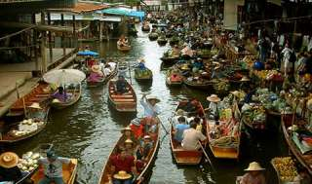

Damnernsaduak Floating Market
(800 Baht / Per Person)
06.30 a.m. Pick up from the hotel.
07.00 a.m. Leave Bangkok for Rajaburi province.
08.30 a.m. Visit coconut sugar home industry.
09.00 a.m. Boat trip to the floating market.
09.30 a.m. Arrive floating market where young find many kind of farm product sold in their sampan boat.
10.30 a.m. Short stop at the handy cleft factory, then return hotel.

Price Exclude :
- Personal Expense
- Service charge 3.5% for paying by credit card charge
*PRICE AND ITINERARY ARE SUBJECT TO CHANGE WITHOUT PRIOR NOTICE*

