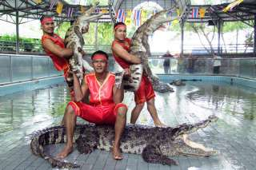
Crocodile Farm (Baht 1,900.- / Per Person) Min. 2 Paxs

11.00 a.m. - 12.00 a.m. Pick up from the hotel
Visit the world's largest crocodile farm, founded in 1950. Samutprakarn Crocodile Farm and Zoo is dedicated to the education, preservation, research and the conservation of wildlife. Experience the thrilling "Crocodile Wresting" stage shows, where the audience is invited to participate and discover a photographer's paradise along the zoo's shady walkways while coming face-to-face with exotic animals.
It is now the world's largest crocodile farm. It is situated at Tambon Tai Ban, 3 kilometers from Samut Prakan town. The farm has over 60,000 crocodiles of different kinds in various pits. Daily shows feature catching crocodiles bare-handed.
Another star attraction for visitors is the elephant show of which performances are held daily every hour from 09.30 a.m. - 04.30 p.m. Furthermore, you can see tigers, chimpanzees, and other animals such as gibbons, turtles, boa constrictors, pythons, birds, camels, hippopotamuses, and of various species of fishes.
05.30 p.m. Return to the hotel
Price Exclude :
- Service charge 3.5% for paying by credit card charge
*PRICE AND ITINERARY ARE SUBJECT TO CHANGE WITHOUT PRIOR NOTICE*

