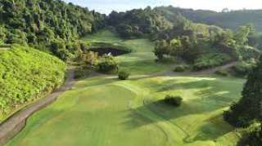
Golf Tour Package Itinerary for the Exclusive Golf Resort Package

This golf tour package can be customized according to your preferences.
Day 1 - Arrival
Arrival Phuket International Airport and transfer to your luxury villa, afternoon take in the Phuket Half Day Island Tour.
Day 2 - Golf at Red Mountain Golf Club
Golf at Red Mountain Golf Club (Phuket's most exciting course; dramatic scenery and great golf).
Day 3 - Golf at Blue Canyon Country Club, Lakes Course
Golf at Blue Canyon Country Club, Lakes Course (excellent layout with the best finishing holes in Phuket).
Day 4 - Departure
Leave your luxury Villa and transfer to Phuket International Airport.

Start Location : Phuket
Tour Length : 4 Days (Length can be adjusted)
Price from : 45,650

Inclusions :
- Accommodation at The Trisara, Ocean View Pool Room
- Daily breakfast
- Two rounds of golf with 1 caddie per golfer
- All airport and golf course transfers
- All transfers via private high top VIP touring van or equivalent
- 24/7 golf hotline staffed by knowledgeable service personnel
- All taxes and compulsory service charges
Exclusions :
- International airfare
- Personal items, drinks, and gratuities
- International and domestic airfare
- Personal items, drinks, and gratuities
Recommended Hotels :
- 5 Star Trisara Phuket Villas & Residences
- We have a wide range of 3 - 5 star hotels available. To meet your preferences and budget please contact us for further information.
Extra Info : Please, note that we have numerous villas and golf resorts available that can be easily combined with this suggested Phuket golf holiday package.

