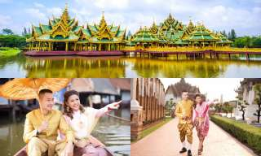
Ancient City Tour + Bicycle Riding
(Operate Only Mon, Wed & Fri / Morning only)
(Baht 1,900.- / Per Person)
Booking Accept For Minimum 2 Person

07.00 a.m. Pick up from the hotel.
07.30 a.m. Leave Bangkok for ancient city.
08.30 a.m. Arrive the ancient city, where you will experience a realistic journey into Thailand's past in only a few hours, saving you many week of travel, Muang Boran houses a number of Art Museum, priceless antiques, there is also an outdoor museum of original architectural structures and a collection of scaled-down replica of historical landmarks. Home of Thailand's culture and natural surrounding are harmoniously unified.
11.00 a.m. Leave ancient city for Bangkok.
12.00 a.m. Return to the hotel

Price Exclude :
- Personal Expense
- Service charge 3.5% for paying by credit card charge
*PRICE AND ITINERARY ARE SUBJECT TO CHANGE WITHOUT PRIOR NOTICE*

