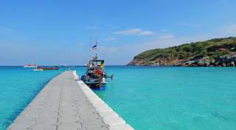
Phuket Raya Island Tour by Speedboat
(Adult 1,700.- Baht / Person Child 1,400 Baht/Person)

It’s about 20 kilometers south of Phuket (sometimes written Racha Island) There are 2 Islands Raya Yai and Raya Noy. The Racha yai (Yai is means big) this is where the accommodation of the two Islands is located. It is a real tropical paradise of clean, sandy beaches and crystal clear waters. There is a major attraction for snorkeling day trip from Phuket. Please see our one day tour details below.

Itinerary
- 08.00 a.m. Pick up from your hotel and transfer to Chalong Pier.
- 09.30 a.m. Departure from Chalong Pier to Raya Island.
- 10.00 a.m. Arrive at Raya Island relaxing on a white sandy beach at Patok Bay.
- Departure from Patok Bayto Kon Kae Bay enjoying snorkeling time with plentiful coral reefs and colorful fishes. Explore the fantastic life with crystal clear water and enjoying snorkeling or relaxing at Siam Bay. Enjoying a great lunch at Raya Island.Spend your time on a white sandy beach.
- 04.00-04.30 p.m. Departure from Raya Island and arrive at Chalong Pier.
Tour Price included :
- Round trip transfer
- Mask & Snorkeling
- Life Jacket
- Life Insurance
- English Speaking Guide
- Lunch
- Fresh fruits
*PRICE AND ITINERARY ARE SUBJECT TO CHANGE WITHOUT PRIOR NOTICE*

