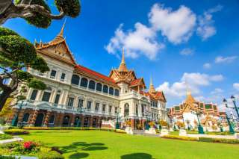

Grand Palace And The Emerald Buddha Temple
( Baht 1,200.-/ Per Person)

07.30 a.m. Pick up from the hotel
08.30 a.m. Visit the emerald Buddha temple and the royal grand palace; This is the perfect introduction to Thailand, the Buddhist faith, regal splendor and tradition. Though no longer the royal residence, it remains the symbol of the kingdom. You'll visit the key attractions around the Grand Palace including Wat Phra Kaew Temple of the Emerald Buddha, Royal Pantheon, Coronation Throne Hall, Royal Reception Hall, and Royal Funeral Hall.
12.00 a.m. Return to the hotel

Price Exclude :
- Personal Expense
- Service charge 3.5% for paying by credit card charge
*PRICE AND ITINERARY ARE SUBJECT TO CHANGE WITHOUT PRIOR NOTICE*

