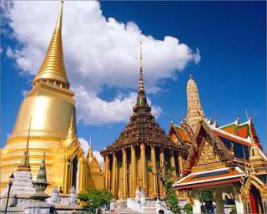
Temple And City Tour (Baht 900.- / Per person)

07.30 a.m. Pick up from the hotel
08.00 a.m. Visit THE LARGEST GOLDEN BUDDHA IMAGE with 505 tons sold gold
08.30 a.m. Visit THE RELINING BUDDHA IMAGE with 46 long and 15 maters high cover in gold leaf
10.00 a.m. THE MARBLE TEMPLE, constructed of marble from curare Italy
12.00 a.m. Return to hotel

Price Exclude :
- Personal Expense
- Service charge 3.5% for paying by credit card charge
*PRICE AND ITINERARY ARE SUBJECT TO CHANGE WITHOUT PRIOR NOTICE*

