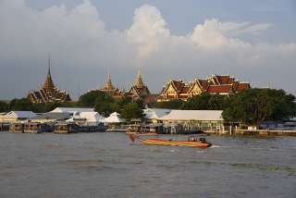
Canal Tour (Baht 2,200.- / Per Person)
Max. 2 Person

06.30 a.m. Pick up from the hotel, transfer to the pier
08.00 a.m. Boat trip, cruising along the river of the king (CHAO PRAYA RIVER) to the old part of Bangkok, enjoy watching interesting life of people who live on the both bank of the river
09.30 a.m. Visit the snake farm (OPTIONAL TOUR), then passing temple of the dawn the reclining Buddha temple and the royal grand palace
11.45 a.m. Return to the hotel
Personal Expense
Price Exclude :
- Service charge 3.5% for paying by credit card charge
*PRICE AND ITINERARY ARE SUBJECT TO CHANGE WITHOUT PRIOR NOTICE*

