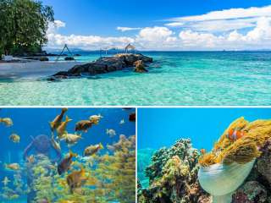
Phuket Coral Island Tour by Speedboat
(Adult 1,300.- Baht / Person Child1,100.- Baht / Person)

Coral Island, known locally as Koh Hae, is a beautiful getaway destination located three kilometers southeast of Phuket. The island features two main beaches, Long Beach and Banana Beach.
It's not called Coral Island for nothing; the snorkeling off Banana Beach is thrilling and if you go out far enough from Long Beach you will also have a lot to discover, at its impressive coral reef.

Itinerary
- 08.00-09.00 a.m. Pick up from hotel and transfer to Chalong pier.
- 09.30 a.m. Departure from Chalong Pier to Coral Island (Koh Hey)
- 09.45-11.30 a.m. Arrival at Coral Island ( Koh Hey )Enjoy the white sandy beach & turquoise water or you can partake in various sea activities such as Seawalking, Diving, Parasailing and Banana Boat.
- 11.30 a.m. - 01.00 p.m. As part of the tour, enjoy our very tasty Thailand's famous cuisine at Hey Restaurant.
- 01.00 - 03.00 p.m. Take your leisure time left through relaxing on the beach or do some sea activities.
- 03.00 p.m. Departure from Coral Island (Koh Hey) to Chalong Pier and return back to hotel.
Tour Price included
- Round trip transfer
- Lunch
- Beach Chair
- Life jacket
- Mask and snorkel
- English Speaking Guide
- Life insurance
Price exclude :
- Personal Expense
- Service charge 3.5% for paying by credit card charge
*PRICE AND ITINERARY ARE SUBJECT TO CHANGE WITHOUT PRIOR NOTICE*

