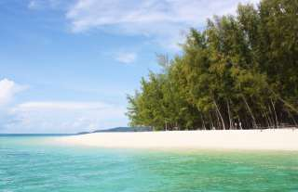
Phuket Phi Phi & Bamboo Island by speedboat (Marina Pier)
(Adult 2,300.- baht / person Child ,1900 baht / person)

One day trip from Phuket to Phi Phi Island is very popular with tourists who do not want to stay at Phi Phi Island. Phi Phi Island is 48 km southeast of Phuket which takes approximately 1 hour by speedboat. Phi Phi Island is a popular tourist destination for travelers. It is one of the most famous and beautiful attractions and the magical landscape of Maya Bay where the movie "The Beach" was filmed.
Itinerary
07.30 - 08.00 a.m. We will pick you up from your hotel and take you to the Royal Phuket Marina Pier.
09.30 a.m. Visit Ao Nui "Camel Rock"
10.00 a.m. Swimming, resting, feeding the wild monkeys at Monkey Beach
10.30 a.m. Visit Viking Cave. Heading to Pileh Lagoon Swim in the emerald waters surrounded by towering cliffs.
11.00 a.m. Snorkeling and discover the fabulously colorful sea wildlife at Loh Sama or Bida island.
11.30 a.m. Arrive at Maya Bay, for swimming in this unique lagoon or relaxing on the Beach.
12.00 a.m. Buffet lunch served at Phi Phi Don.
01.30 p.m. Snorkeling at Hin Klang ( great coral reef)
02.30 p.m. At leisure on Bamboo island, swimming, relaxing and sunbathing
03.30 p.m. Time to go back
04.30 p.m. Arrival at Royal Phuket Marina.

Tour Price included
- Hotel transfers, English speaking guide, speedboat trip and entry fees to the national park.
- On board: soft drinks, water, ice and fresh fruits
- Lunch: meal, drinking water, coffee and tea
- Full snorkeling equipment: lifejacket, mask and snorkel
- All safety equipment and insurance are provided
Price exclude :
- Personal Expense
- Service charge 3.5% for paying by credit card charge
- Prices and itineraries are subject to change without prior notice.
*PRICE AND ITINERARY ARE SUBJECT TO CHANGE WITHOUT PRIOR NOTICE*

