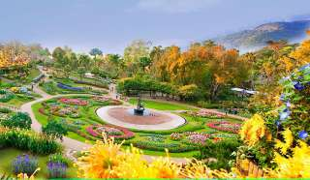
Wat Phra That Doi Tung & Doi Tung Royal Villa & Mae Fha Luang Garden

Half Day Tour ( 08:30 a.m. - 12:30 a.m. / 01:00 p.m. - 05:00 p.m )
Drive up to the highest mountain peak on the Thai/Burma border, Doi Tung is 2000 meters above sea-level. In the past, the forest area around Doi Tung was destroyed by shifting slash-and-burn cultivation. Until 1987, Doi Tung Development. Project was established according to the King's Mother initiative. Visit the most sacred and elegant temple, Wat Phra That Doi Tung , built in A.D. 911 and it is believed that the left collarbone of Lord Buddha is enshrined in the twin pagodas. From here, a spectacular view can be seen when the weather is clear. Continue to The Royal Villa of the late Princess Mother (the King's mother), the most beautiful combination styles of the northern Thai and Swiss winter villa. Also visit a beautiful botanical – Mae Fha Luang garden near the palace.

Half Day Tour  (Price Per Person in Thai Baht) | 1 | 2 | 3-5 | 6-8 | JoinTour
Wat Phra That Doi Tung & Doi Tung Royal Villa & Mae Fha Luang Garden | 3400 | 2000 | 1700 | 1500 | -
*PRICE AND ITINERARY ARE SUBJECT TO CHANGE WITHOUT PRIOR NOTICE*

