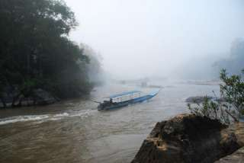
Mae Kok River Cruise, Lahu & Karen Hill Tribe Villages
Half Day Tour (08:30 a.m. - 12:00 a.m. / 01:00 p.m. - 04:30 p.m )
Take a ride on the opened air long tailed speed boatalong the famous Kok River to visit an elephant training village and the Karen Hill tribe, the most talented hill tribe in Thailand for elephant training. This is your chance to enjoy an elephant ride around the camp (supplement will be paid on the spot). Then proceed to a Lahu village upstream to visit a less frequented tribe and a hot spring before taking a boat back to Chiang Rai.

Half Day Tour  (Price Per Person in Thai Baht) | 1 | 2 | 3-5 | 6-8 | Join Tour
Mae Kok River Cruise, Lahu & Karen Hill Tribe Villages | 2900 | 2000 | 1500 | 1200 | -

*All price are subject to change without prior notice and may surcharge for stay over major holiday*

