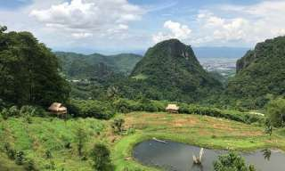
Mae Sai , Golden Trlangle And Chang Saen Tour

Half Day Tour (08:30 a.m. - 12:00 a.m. / 01:30 p.m. - 05:00 p.m)
Enjoy a trip to Mae Sai, on the northern Thai-Burmese border, and the Golden Triangle, where the borders of Thailand, Burma, and Laos meet. Excursion to Chiang Saen and visit some magnificent ruins and ancient temples.
*PRICE AND ITINERARY ARE SUBJECT TO CHANGE WITHOUT PRIOR NOTICE*

