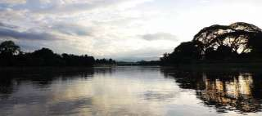
Excursion Along Mae River
(2,200.- Baht / Person ) Min 2 Person)

(08:30 a.m. - 12:00 a.m. / 02:00 p.m. - 05:30 p.m.)
Visit Karen Hill tribe Village by local motor boat along the scenic Mae Kok River. Enjoy a 20 minutes elephant ride through Karen Village.
Include : Private boat / car, English speaking guide, elephant ride (30 minute)
Exclude: Drink

*PRICE AND ITINERARY ARE SUBJECT TO CHANGE WITHOUT PRIOR NOTICE*

