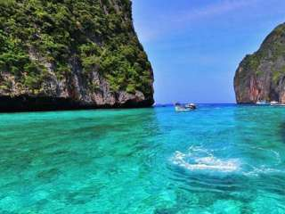
Phuket City Tour Half Day
(Adult 900.-Baht / Person Child 800.- Baht / Person)

Itinerary
>> Pick up from hotel and transfer for sightseeing as per following venues:
- Prom Thep Cape - The beautiful peninsular adjacent to the famous Nai Harn Beach. Phuket’s southernmost point, which is the perfect place to view spectacular sunset.
- The driving passing through the Rawai Beach where a local Sea Gypsy’s Village is located, most of people here are fishermen. They are the local people who have their old life style and unique characteristic, which is different from Phuket people in town, and the original tradition of they believe and respects are also different.
- Visit of Chalong Temple (Wat – Chalong), this temple is very famous in its monks since previous times. It is the place where stands the cast statue of Luang Por Cham, who helped the people put down the Ang-yee, or Chinese Coolie Rebellion in 1876 during the reign of King Rama V. There are also other statues of famous monks, which gain the respect from all people of Phuket.
- Driving to Phuket town for sightseeing around, especially to see the architecture of Sino-Portuguese that in the previous time most of people in Phuket built their houses by mixed the style of Chinese and Portuguese into their house’s pattern. You will see how beautiful and spectacular architecture of the houses. Right now our Thai government has protected and kept these houses for the fortune people to see and educate in the future.
- Visiting World Gems Gallery, short break stop to take a rest. Moreover, with the world’s largest showroom where you can find the most extensive collections of world class’s jewelry product which is created by the in-house factory. The store also present the multi vision slides genuine natural stones with life time service guaranteed before return to your hotel
- Remarks: Please note that all the above mention program is subject to change without prior notice due to the weather conditions, or upon to the client’s requirement or the appropriately of its routing and some programs could be cut off due to the availability of times and limitation
Tour included :
- Transportation
- English speaking Guide
Price exclude :
- Personal Expense
- Service charge 3.5% for paying by credit card charge

*PRICE AND ITINERARY ARE SUBJECT TO CHANGE WITHOUT PRIOR NOTICE*

