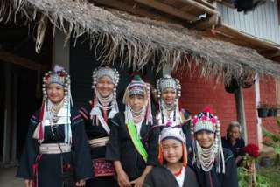
3 Days 2 Nights Trekking
(3,900.- Baht/Person) Min. 2 Person)
Start at 10 A.M.
Travel by long tail boat to Karen Village , riding and elephant before to waterfall and Lahu Village where you will spent the night. The next day trek through the forest and fields lunch in northern Style at village. Stop at waterfall and enjoy swimming. Before hiking to Akha , explore the way of life. Overnight in the village. After breakfast , to forest and Lahu Village. Continue on to Hot Spring , before returning to Chiang Rai by car.
Exclude : Elephant ride, Drink.
Include : Transportation , English speaking guide , Accommodation 2 night at Hill tribe village , Meals.
*PRICE AND ITINERARY ARE SUBJECT TO CHANGE WITHOUT PRIOR NOTICE*

