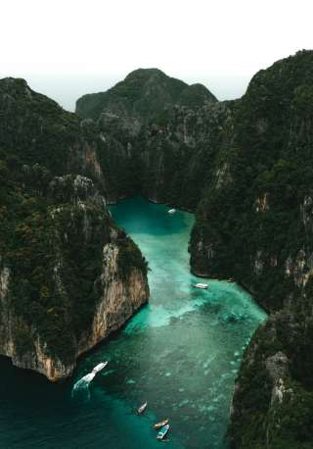

Phi Phi Islands Tour by Cruise (Ratsada Pier)
(Adult 1,250.- Baht / Person Child 1,150.- Baht / Person)

Maybe a trip to Phuket is not complete without a visit to these two stunningly beautiful Phi Phi Island: Phi Phi Don (the larger of the two) and Phi Phi Lay. Phi Phi Lay with its only beach, tucked away in amazingly picturesque. Maya Beach was the recent site for the filming of the movie “The Beach”. However, as the government protect then there is no development or accommodation, which makes it a perfect island gateway.
Phi Phi Don has numerous idyllic tropical beaches lining its southern and eastern shores, with numerous bungalow style hotels. The main tourist center is Ton Sai Bay, a small and bustling village, with a string of bungalows, hotels, shops and restaurant. Despite the many visitors every day, the natural beauty of the place still remains.

Itinerary
- 07.15-07.30 a.m. Pick up from your hotel
- 08.30 a.m. Departure from Rassada Port Phuket
- 10.00 a.m. Arrival in Phi Phi Don (transportation port)
- 11.00 a.m. Snorkeling around Maya Bay areas (The Beach Movie)
- 12.00 a.m. Sightseeing around Phi Phi Lay, Loh Samah Bay, Pileh Bay, and Viking Cave
- 12.30 a.m. Buffet Lunch at the most beautiful seaview restaurant of Phi Phi DonAfter lunch free time at l eisure on the beach
- 02.30 p.m. Departure from Phi Phi to Phuket
- 04.15 p.m. Arrival Ratsada Port Phuket
- 04.30-05.30 p.m. Arrive to your hotel after a pleasant trip
Tour Price included :
- R/T Transfer from/to your hotel, SIC basis
- Round trip boat transfer to Phi Phi, join basis
- Mask and Snorkel , fresh water, shower
- Sightseeing around Phi Phi Lay
- Buffet Lunch
- Life Jacket
- Full insurance
- Coffee, Tea, Soft drinks, Fresh fruits, Snacks on board
- Escort Guide (English speaking)
Price exclude :
- Personal Expense
- Service charge 3.5% for paying by credit card charge
*PRICE AND ITINERARY ARE SUBJECT TO CHANGE WITHOUT PRIOR NOTICE*

