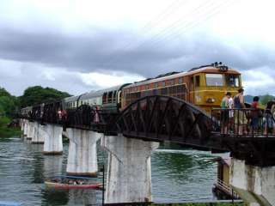
Damnernsaduak Floating Market , The River Kwai ,
The Tiger Temple
(2,200.- Baht / Per Person)

07.00 a.m. Pickup from the hotel , Then transfer to Rachaburi province
- Take A Boat Trip To The Floating Market
- Arrive Floating Market , Where you can buy Fruits , Flowers, and many kind of Farm Products Sold in Theirs Sampan Boat
- International Buffet Lunch at the restaurant.
- Visit The War Museum.
- Visit The Bridge over the River kwai and the death railway.
- Transfer to The Tiger Temple.
- Leave The Tiger Temple for Bangkok.
- Return to the hotel.
Price Exclude :
Personal Expense :
- Service charge 3.5% for paying by credit card charge
*PRICE AND ITINERARY ARE SUBJECT TO CHANGE WITHOUT PRIOR NOTICE*

