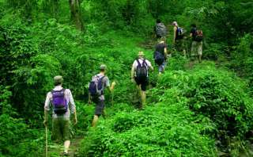
2 Days 1 Night Trekking
(3,200.- Baht/Person) Min. 2 Person)
Start at 10 A.M.
Begin your adventure by traveling up the Kok River in a long tail boat. Stop at a Karen Village, ride an elephant and have lunch. Continue on to waterfall, Lahu Village where you will overnight. In the evening enjoy dinner, performance massage can be arranged for those interested. Wake up to the sound roosters and rice pounding. Trekking through the forest, fields and tea plantation to waterfall explore an Akhu and Lahu Villages, and continue on to Hot spring before returning to Chiangrai by car.

Include : Transportation , English speaking guide , Meal , Accommodation for 1 night at Hill
Exclude : Elephant ride , Drink.
*PRICE AND ITINERARY ARE SUBJECT TO CHANGE WITHOUT PRIOR NOTICE*

