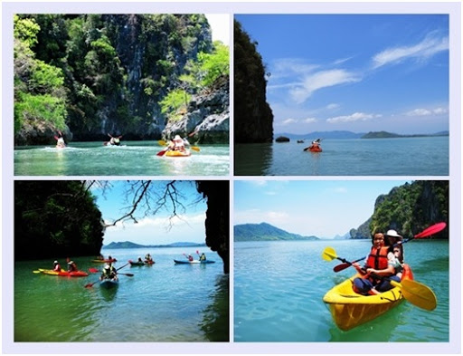
Krabi Kayaking At Talabeng Island
( Adult 1,500 Baht/Person Child 800 Baht/person )
Time: 08.30 am. – 15.30 pm.
- Pick up from your hotel
- Arrive at Tungyeepeng pier
- Touch the nature of Tungyeepeng Village ( Mangrove Forest )
- Monkey sightseeing and feed them with banana ( Sitting By Long tail boat )
- Take long tail boat to Talabeng Island
- Start kayaking around Talabeng Island
- Explore Talabeng Sea Cave
- Sitting long tail boat to BuBu Island for lunch
- Enjoy swimming, sunbath, relax at BuBu Island
- Go back to Koh Lanta
- Transfer back to your hotel
Tour Itinerary
Tour include : Round trip transfer, Lunch, fruits, soft drink , Life jacket , Local Guide ,Insurance
Exclusions :
- Optional tours or excursions not mentioned in the program
- Other meals not mentioned in the program
- Personal expenses
- Services change 3.5% pay by credit cards
*PRICE AND ITINERARY ARE SUBJECT TO CHANGE WITHOUT PRIOR NOTICE*

