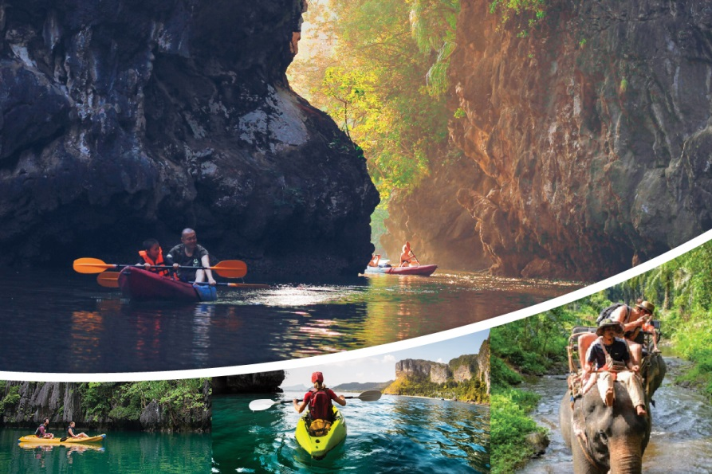
Krabi Kayaking And Elephant Riding
( Adult 1,900 Baht/Person Child 1,300 Baht/Person )

08.30 am - 04.30 pm See the Sea Cave at Bor Thor Village Trip Itinerary
- Pick up from your Krabi hotel
- Transfer to Bor Thor Village by "Mini Bus"
- Takes approximately 40 minutes.
- Start paddling through the magnificent mangrove forest.
- Paddle to see "Tham Lod Tai" where a tunnel takes you under the limestone mountain. There are many splendid stalactite and stalagmites gathered at the entrance.
- Paddle to see "Tham Pee Hua Toh" which is a spacious airy cave.
- On the wall of this cave are many prehistoric paintings and the layers of archeological shells.
- Lunch is served at the Riverside restaurant.
- Continue to Elephant camp.
- You will trek through beautiful natural surroundings.
- Time to enjoy a refreshing swim in a cool stream.
- Experience new thrills feeding the elephants. You can buy souvenirs at this times also.
- Transfer back to your hotel.

Tour Itinerary
Include : Lunch, Life jacket, Fruit, Drinking water, Insurance, Dry bag, Coffee, Tea, Soft drink, Tour guide with license.

Exclusions :
- Optional tours or excursions not mentioned in the program
- Other meals not mentioned in the program
- Personal expenses
- Services change 3.5% pay by credit cards
Remark :
- Operate high season only
- This program is subject to change according to the weather and sea conditions
*PRICE AND ITINERARY ARE SUBJECT TO CHANGE WITHOUT PRIOR NOTICE*

