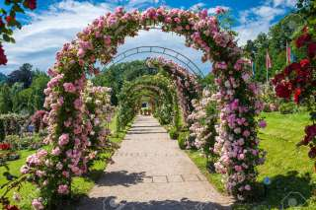
Damnernsaduak Floating Market Lunch Cultural Show At Rose Garden
Elep. & Croc. Theme Shop
(1,800.- Baht / Per Person)

06.30 a.m. Pick up from the hotel
07.00 a.m. Leave Bangkok for Rachaburi province
08.30 a.m. Visit coconuts sugar home industry
09.00 a.m. Boat trip to The Floating Market
09.30 a.m. Arrive Floating Market where you find many kinds of farm products sold in their Sampan boat
10.30 a.m. Short stop at the handy craft factory
12.00 a.m. Visit the Samphran Elephant Ground & Zoo for International Buffet Lunch, after lunch see the Crocodile Wrestling Show and The Elephant Theme Show; the great elephant show in Thailand

Price Exclude :
Personal Expense:
- Service charge 3.5% for paying by credit card charge
*PRICE AND ITINERARY ARE SUBJECT TO CHANGE WITHOUT PRIOR NOTICE*

