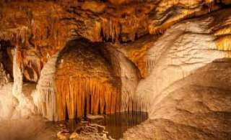
Multi Caves Visit (1,600 Baht/Person)

Apart from the coastline covered with huge limestone karsts, Krabi is also famous for its abundant caves. The first cave we will visit is Tiger Cave in Tham Sua Temple The last tiger of Krabi inhabited in this cave. In the temple, there are some small monk huts around the valley. This mountainous area is suitable for practicing meditation. Besides, there are a 1000-year-old tree and the scenic viewpoint with 1037 steps up the mountainside. Lod Cave is a limestone tunnel where you can admire the amazing stalactite hanging from the cave roof. It is an exciting trip through a passage to the other side of the mountain where you will find yourself surrounded by Limestone Mountain. Pee Hua Tho Cave is a pre-historic, condominium-like cave consisting of dining area and the bedroom area decorated with hundreds of pre- historic paintings. The last one is a cave in the "Tan Bok Khor Ranee" National Park where fresh water comes out of the cave. If you like, it is possible to swim upstream into the cave.

Tour Itinerary
Scheduled Time : 09.00 a.m. - 04.00 p.m.
Tour Include : lunch, fruits, drinking, water, beach tower life jacket, snorkeling equipment, English speaking guide, insurance and first aid kit.
Pleased Bring : camera, swimwear, sunglasses, sun-lotion a hat or cap if you head is sensible to the heat and beach slippers.

*** This program is under the limitation of the weather conditions ***
*PRICE AND ITINERARY ARE SUBJECT TO CHANGE WITHOUT PRIOR NOTICE*

