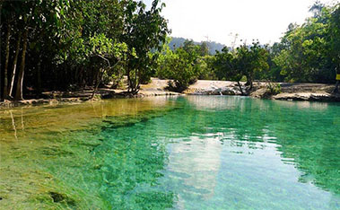
Silk Route & Hot Springs (1700 Baht/Person)

At Nue Klong Fruit Market, you will see local people come out to buy vegetables, meat, and some ingredients to prepare their homemade meals, and experience the Thai ways of life. it is a good moment to buy the tropical, fresh fruits. Klong Thom was once a trading station on the ancient marine silk route. Millions of ancient beads are the evidence. Some of these artifacts are exhibited in the museum of wat klong thom. The Hot Spring/Hot Waterfall of klong Thom are wonderful and perfect for soaking in after a long day tour. The minerals and the temperature (38 - 40c) of the springs are ideal for hydrotherapy bath. A walk in the "wild" jungle gives you the opportunity to observe the natural wildlife. if lucky you will see the rare pitta gurney birds thought to be extinct until discovered in this small jungle only 14 years ago. This walk leads you to the crystal pool.

Tour Itinerary
Scheduled Time : 09.00 a.m. - 04.00 p.m
Tour Include : lunch, fruits, drinking water, towel, first aid kit, insurance, and English speaking guide.
Pleased Bring : sunglasses, sun-lotion, camera, dry clothes to change and walking shoes.
*PRICE AND ITINERARY ARE SUBJECT TO CHANGE WITHOUT PRIOR NOTICE*

