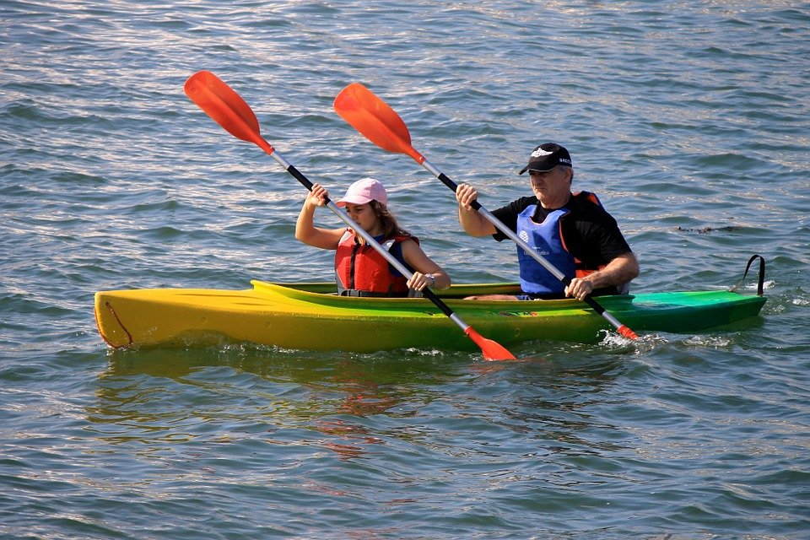
Sea Canoeing : Cave (1,500 Baht/Person)

On the cave route, you will enjoy canoeing along the river with the beautiful mangrove scenery on both sides. The highlight of the trip is to paddle through the marvelous caves. You will see the stalagmite and stalactite of lod cave and visit the pee hua tho cave (the skull cave) with interesting pre-historic paintings. Once you paddle through the light cave, you will find yourself in the fascinating paradise room where you can enjoy the peaceful atmosphere and beautiful scenery (we could access only during high tide). the next visit is the dark passage cave through which you paddle to reach the huge, stunning room awaiting for you to explore. At taan bok khor ranee national park it is a good idea to refresh yourself after a long day canoeing by swimming in the waterfall which comes out of a mysterious cave.
Tour Itinerary
Scheduled Time : 09.00 a.m. - 04.00 p.m.
Tour Include : lunch, fruits, drinking water, coke, beach towel, life jacket, canoeing equipment, first aid kit, insurance, and English speaking guide.
Pleased Bring : swimwear, sunglasses, sun-lotion, camera, clothes and beach slippers.
*** This program is under the limitation of the weather conditions ***
*** Basic training provided ***
*PRICE AND ITINERARY ARE SUBJECT TO CHANGE WITHOUT PRIOR NOTICE*

