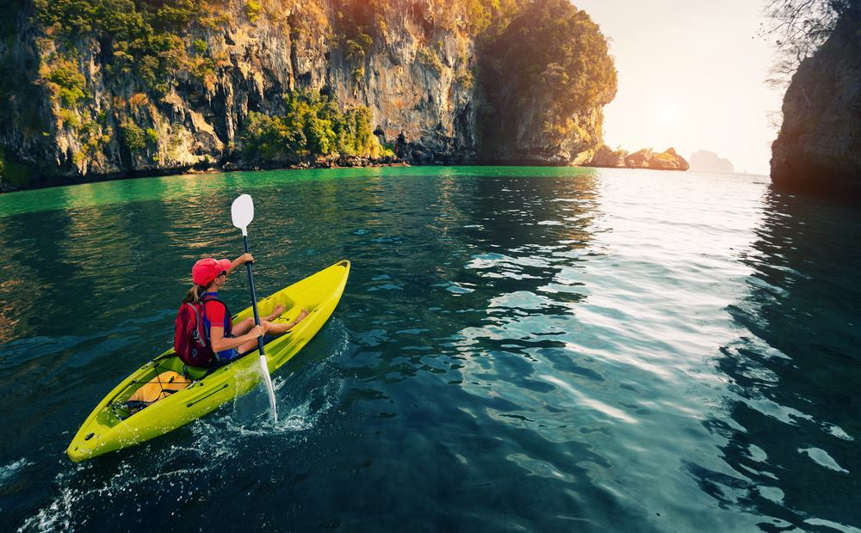
Sea Canoeing : Canyon (1,300 Baht/Person)

Canyon is a terrific place to have an adventure by canoeing through the mangrove forest along the mountain edges, where you can experience the ecology of the whole area and see lots of animals. If lucky, you will see monkeys and gibbons, which always give us a chance to have eye contact with them. In this mangrove forest, there are the secret rooms where you can feel the silence of the nature. After exiting the mangrove forest, you will reach the highlight of the trip which is the magnificent canyon, the limestone karsts cliffs covered with wild flora. Besides, you will visit the "high-rise apartment" , Sa Kaew Cave, a naturally built cave rising in 4 stories. Those who are strong-legged and courageous can try to climb it!
Tour Itinerary
Scheduled Time : 09.00 a.m. - 04.00 p.m.
Tour Include : lunch, fruits, drinking water, coke, beach towel, life jacket, canoeing equipment, first aid kit, insurance, and English speaking guide.
Pleased Bring : swimwear, sunglasses, sun-lotion, camera, clothes and beach slippers.
*** This program is under the limitation of the weather conditions ***
*** Basic training provided ***
*PRICE AND ITINERARY ARE SUBJECT TO CHANGE WITHOUT PRIOR NOTICE*

