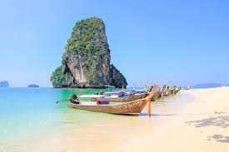
Sand, Sea, Snorkeling (1,000 Baht/Person)

We will take you to the best Beaches, Islands, and Coral Reefs. Krabi has, not only the wonderful underwater world where you gonna snorkel among the multi-colors friendly fish...but you'll also find the magnificent scenery of the islands even when you are Just enjoying your boat ride. The island beaches are marvelous that is why we will enjoy our lunch on the beautiful white sand. On the way back you will stop at Phra Nang Beach and see Phra Nang Cave. Here it will be optional to relax on the beach or make a beautiful walk along the mountain cliffs on Ao Nam Mau Beachand through Railey Village and meet up with the boat at Railey Beach.
Tour Itinerary
Scheduled Time : 09.00 a.m. - 04.00 p.m.
Tour Include : lunch, fruits, drinking, water, beach tower life jacket, snorkeling equipment, english speaking guide, insurance and first aid kit.
Pleased Bring : camera, swimwear, sunglasses, sun-lotion a hat or cap if you head is sensible to the heat and beach slippers.
*** This program is under the limitation of the weather conditions ***
*PRICE AND ITINERARY ARE SUBJECT TO CHANGE WITHOUT PRIOR NOTICE*

