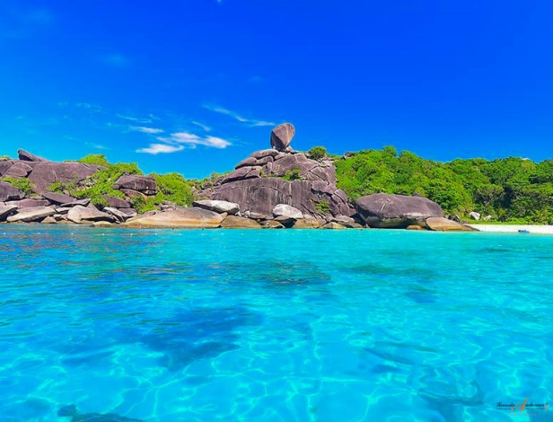

Krabi One Day Trip To Similan Islands
( Adult 2,800 Baht/Person Child 2,300 Baht/Person)

Time: 06.30 am. – 16.30 pm
- 06.30-07.00 am. Pick up from hotel and transfer to Thuplamu Pier.
- 08.30 am. Meet tour guide and Departure to Similan island s by speed boat
- 10.00 am. Snorkeling in crystal blue water at Stonehenge the n head to Na Beach on koh miang (Islandno.4)enjoy the beach and explore the island. Discover honeymoon bay.
- 12.00 pm. Enjoy Thai delicious lunch
- 01.00 pm. Snorkeling at Koh Ba Ngu (Island no.9) then head to Donald duck Bay at Koh Similan (Island no.8) where you can relax on the beach or hike to the view point
- 03.00 pm. Depart Similan Island after an amazing day.
- 04.30 pm. Arrive at Thuplamu pier and transfer back to hotel.
Tour Itinerary
Tour include : Tour guide ,lunch ,soft drink, hotel transfer ,insurance ,snorkeling equipment.
Exclusions :
- Optional tours or excursions not mentioned in the program
- Other meals not mentioned in the program
- Personal expenses
- Services change 3.5% pay by credit cards
Note :
- Operate high season only.
- This program is subject to change according to the weather and seaconditions.
*PRICE AND ITINERARY ARE SUBJECT TO CHANGE WITHOUT PRIOR NOTICE*

