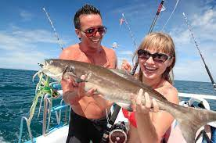

Krabi Full Day Fishing Trip ( Adult 2,800 Baht/Person )

Time: 08.30 am. – 04.30 pm.
08.00 - 08.30 am. Pick up from your hotel.
09.00 am. Depart from Chalong Bay.
09.30 am. Trolling starts.
12.00 am. Lunch served on board and time for swimming.
01.00 pm. Bottom fishing.
02.00 pm. Trolling starts again.
04.00 pm. Arrive back at Chalong Bay.
04.30 pm. Transfer back to your hotel.

Tour Itinerary
Tour include : Lunch, Soft drinks, Equipment ,Transfer around trip, Insurance.
Exclusions :
- Optional tours or excursions not mentioned in the program
- Other meals not mentioned in the program
- Personal expenses
- Services change 3.5% pay by credit cards
*PRICE AND ITINERARY ARE SUBJECT TO CHANGE WITHOUT PRIOR NOTICE*

