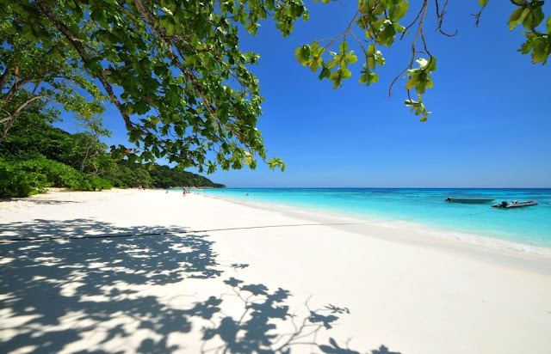
Krabi One Day Trip To Tachai Island
( Adult 4,200 Baht/Person ,Child 2,500 Baht/Person )
Pick up from hotel to Baan Nam Kem Pier
Time: 06.00 am. – 04.45 pm.
- 08.30 am. Depart to Virgin Island by speed boat
- 10.00 am. Snorkeling at the south of koh Tachai “The virgin fantasy reefs’’
- 11.00 am. Enjoy the amazing beach of Tachai 750 meters long ,get relax on the beach
- 12.00 pm. Buffet lunch on the beach
- 01.00 - 03.00 pm.
* Relaxing on the white sandy beach
* Thai Hairy legged crab
* Black tipped baby sharks
* Optional snorkeling at the coral Garden reefs by national
* Optional hike to koh Tachai viewpoint
- 03.30 pm. Depart to Baan Nam Kem pier
- 04.45 pm. Arrive at Baan Nam Kem pier and transfer back to hotel.
Tour Itinerary
Tour include : Tour guide ,lunch ,soft drink, hotel transfer ,insurance ,snorkeling equipment
Exclusions :
- Optional tours or excursions not mentioned in the program
- Other meals not mentioned in the program
- Personal expenses
- Services change 3.5% pay by credit cards
Note :
- Operate high season only ,
- This program is subject to change according to the weather and sea conditions
*PRICE AND ITINERARY ARE SUBJECT TO CHANGE WITHOUT PRIOR NOTICE*

