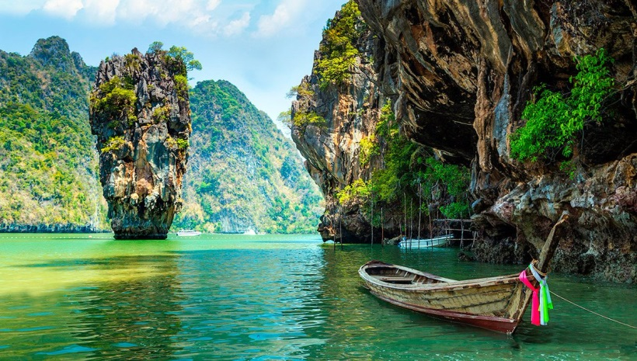
Krabi Full Day Trip To Phang Nga Bay
( Adult 2,800 Baht/Person , Child 1,800 Baht/person )

Time: 08.30 a.m. – 05.00 p.m.
- 08.30 a.m. Pick up from hotel and transfer to the Pier.
- 09.30 a.m. Depart from the pier to Panak Island and Hong Island for canoeing and sightseeing.
- 12.30 p.m. Have a great lunch
- 01.30 p.m. Visit James bond Island and Khao Ping kan
- 03.00 p.m. Arrive at Lawa Island (Naka Island) with its beautiful beaches, for a relaxing and swimming
- 04.00 - 05.00 p.m. Return to the Pier and transfer back to hotel
Tour Itinerary
Tour include : Land transfer, Fruit, Soft drink, Lunch, Guide, Canoeing gear, Life jacket, Full insurance

Exclusions :
- Optional tours or excursions not mentioned in the program
- Other meals not mentioned in the program
- Personal expenses
- Services change 3.5% pay by credit cards
Note : Program is subject to change according to the weather and sea conditions
*PRICE AND ITINERARY ARE SUBJECT TO CHANGE WITHOUT PRIOR NOTICE*

