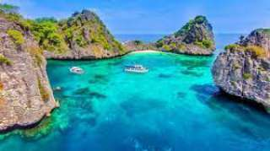
Krabi One Day Trip To Koh Rok
( Adult 1700 Baht/Person Child 850 Baht/person )
Time: 08.30am. – 16.00 pm.
- 08:30 : the boat Start from Klong Dao Beach .And pick up guests from other beach (pick up by speed boat)
- 10:00 : Arrive at Koh Rok and start snorkeling from the boat for 1 hour.
- 11:30: Stop on the island, you may relax on the beach for sun bathing, walking around the island or snorkeling near the beach.
- 12:30: Lunch on the beach.
- 13:30 : Set for the last stop, and it the best spot for snorkeling of the trip.
- 15:00 : Depart from Koh Rok and back to Koh Lanta.
- 16:00 : Arrive Koh Lanta.

Tour Itinerary
Tour include: | Snorkel, mask & fin, lunch, soft drink, drinking water, fruits and  National park fee.
Exclusions: | - Optional tours or excursions not mentioned in the program  - Other meals not mentioned in the program  - Personal expenses  - Services change 3.5% pay by cardit cards

PRICE AND ITINERARY ARE SUBJECT TO CHANGE WITHOUT PRIOR NOTICE

