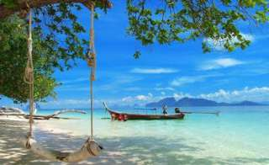
Krabi One Day Trip To 4 Islands (Trang)
( Adult 1,700 Baht/Person Child 850 Baht/person )

Time : 08.30 am. – 04.00 pm.
08:30 a.m. : Start from Klong Dao Beach. And pick up guests from other beach (pick up by speed boat)
09:30 a.m. : Arrive at Koh Ngai and start snorkeling from the boat for 1 hour.
10:30 a.m. : Visit the Emerald Cave and stay there for about another hour.
12:00 a.m. : Arrive Koh Kradan and relax on the beach or snorkeling.
12.45 a.m. : Lunch on the beach.
02:00 p.m. : Depart from Koh Kradan and to Koh Chuack for snorkeling again.
03:00 p.m. : Depart from Koh Chuack and set to Koh Lanta.
04:00 p.m. : Arrive Koh Lanta.

Tour Itinerary
Tour include : Snorkel, mask & fin, lunch, soft drink, drinking water, fruits and national park fee.

Exclusions :
- Optional tours or excursions not mentioned in the program
- Other meals not mentioned in the program
- Personal expenses
- Services change 3.5% pay by credit cards
*PRICE AND ITINERARY ARE SUBJECT TO CHANGE WITHOUT PRIOR NOTICE*

