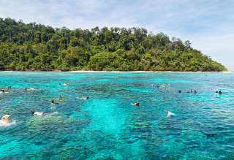
Krabi Full Day Lanta Adventure Tour
( Adult 2,200 Baht/Person Child 1,700 Baht/person )

Time: 08.00 am. – 05.00 pm.
- Pick up from your hotel
- The experience and enjoyment you will discover from spending time with elephant trekking
- Tungyeepeeng village mangrove tour by kayaking or long tail boat
- Feeding monkeys at mangrove forest
- Visit fish farm
- See the producing of making rubber plate
- Having lunch at Khao Yai restaurant
- Visit and shopping at Lanta Old Town (where life goes on, virtually unchanged, much as it has done for the last 100 years)
- Visit Sea Gypsy village name “Sung Ga U”
- Relax and swimming at kan Tieng Bay,enjoy your time
- Transfer back to hotel
Tour Itinerary
Tour includes :
Roundtrip transfer, experience guide, life jacket, insurance, soft drink, fruits lunch at view point restaurant.
Exclusions :
- Optional tours or excursions not mentioned in the program
- Other meals not mentioned in the program
- Personal expenses
- Services change 3.5% pay by credit cards
*PRICE AND ITINERARY ARE SUBJECT TO CHANGE WITHOUT PRIOR NOTICE*

