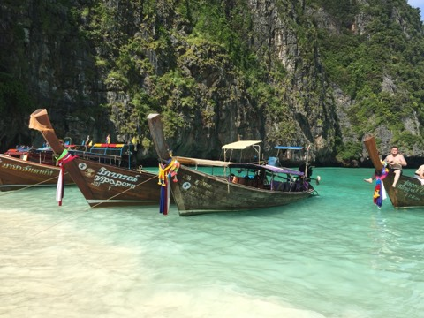
Krabi One Day Tour Phi Phi By Speed Boat
( Adult 1,500 Baht/Person Child 1,000 Baht/person )
Time: 09.15 am. – 03.00 pm.
08.00 am. Pick up service from the hotel.
09.00 am. Depart from Nopparattara Pier.
Bamboo Island Swimming snorkeling and Relax on the beach.
Phi Phi Lay
Viking Cave where they can get Bridnet
Pi Leh Bay Beautiful lagoon and Crystal pool.
Loh sama Bay enjoy with colorful fish.
Maya Beach the location of the famous movies “The Beach”
Phi Phi Don Lunch time at areeda restaurant
Shopping and relax on the beach.
Monkey beach for more fun snorkeling. Colorful coral
04.30 pm. Arrive back at your hotel.

Tour Itinerary
Exclusions :
- Optional tours or excursions not mentioned in the program
- Other meals not mentioned in the program
- Personal expenses
- Services change 3.5% pay by credit cards
*PRICE AND ITINERARY ARE SUBJECT TO CHANGE WITHOUT PRIOR NOTICE*

